Project Cycle Taxonomy

Key Definitions

**Project:** A project encompasses a set of specific tasks or activities aimed at completing a defined set of deliverables. It includes specific objectives and resources assigned to perform the work. It is divided into different stages, hereafter also called project status.

**ID - Identification:** First stage of a project when a Business Developer (BD) identifies an interesting opportunity and starts to analyze it. The BD enters the project into the Tender Board.

**PA - Pipe action:** The project still remains in the stage of being announced as a forecast by the Contracting Authority; from this point on the project requires the implication of more people on top of the BD - like for instance a Project Manager - to work more actively its preparation.

**PNF - Pipe not followed:** Status when a project is dropped during the forecast phase.

**EP - EoI under preparation:** This stage starts with the publication of the Service Procurement Notice or call for Expression of Interest (EoI) and finishes with the deadline of the EoI.

**EW - EoI awaiting results:** Stage after the EoI deadline until receipt of the shortlist results.

**EC - EoI cancelled:** Status when a call for EoI is cancelled.

**EL - EoI lost:** Status when the Consortium isn’t shortlisted.

**ENF - EoI not followed:** Status when one decides not to follow the EoI.

**TP - Tender preparation:** This stage starts with the Shortlist Notice/the reception of the Tender Dossier and ends with the tender deadline.

**TW - Tender awaiting result:** Stage when the tender has been submitted and the Consortium is waiting for the award results.

**TC - Tender cancelled:** Status registered when the bidding process is cancelled by the Contracting Authority.

**TNF - Tender not followed:** Status registered when one decides not to submit a tender.

**TL - Tender Lost:** Status registered when a tender is lost.

**PWC - Project won/contracting:** Stage between the tender award notice and contract signature.

**CC - Contract cancelled:** Status when the contracting process is cancelled by the Contracting Authority after an award notice was received.

**PP - Project preparation:** Stage between contract signature and execution phase. For EC projects, the starting date of the execution phase is mentioned in an administrative order.

**INC - Inception:** When described in the ToR,initial period of the execution phase of the contract used to validate assumptions, deliverables and mobilisation requirements presented in the technical proposal. This stage finishes with the approval of the inception report. If no inception period is required, the project starts with the following stage (RUN).

**RUN - Running / Project Operation:** The execution phase of the contract, which begins with the approval of the inception report and finishes with the start of the Project Closing stage (PC).

**PS - Project suspended** (for EC framework contracts)**:** Period suspending the execution phase, by decision of the Contracting Authority.

**PC - Project cancelled:** Final status registered when the project is cancelled by the Contracting Authority during the implementation.

**PD - Project dropped:** Final status registered when the project is cancelled by the contractor.

**PCL - Project closing:** Last stage of the execution phase of the contract during which all project activities and actions are being closed and the final report is prepared. The end of this stage implies the end of the performances charged to the Contracting Authority, as defined in the contract.

**CCL - Contract closure:** Stage at the end of the project, starting when the performances are closed and including the following activities: submission and approval of the final report, project financial audit, final invoice, arbitration procedure (when necessary), final payment by the Contracting Authority, cancellation of the bank guarantee with closure of the project accounts and the completion/verification of the closure dossier.

**CF - Contract finished:** Final status registered when the project becomes inactive, all actions are finished and the project is passed to the archive.

**FIN - Final debrief:** Process organised after the registration of a final status (ex. Pipe not followed, Tender Cancelled, contract finished, etc.) where the technical, financial and expert aspects are evaluated by the company; briefing between all units to ensure proper communication flows.

Glossary:

*(Terms in alphabetical order)*

**Consortium:** Exclusive temporary association of consulting companies organised for the submission and the implementation of a project.

**Consortium agreement:** Legally binding document describing the principles of cooperation between consortium partners at tendering and implementation stage. As a minimum, this document contains a description of the respective partners’ role, responsibilities, timing for service delivery, liability and minimum quality standards on services, project management and quality assurance mechanisms as well as remuneration package for services rendered (margin and revenue share, including direct costs allocation).

**Contracting Authority:** Public organisation financing the contract.

**Expression of interest:** Application document submitted to the Contracting Authority in response to a Service Procurement Notice, comprising information on the consortium composition, technical expertise (project references), financial and staff data.

**Financial offer:** Second part of the offer providing financial information. For fee-based contracts, the financial offer is composed of a breakdown of fees per Expert category and a split of use of man-days per month per category of Expert.

**Forecast notice:** Notice on a future project published by the Contracting Authority; the forecast notice notifies potential candidates that a project will be launched and describes the future project’s objectives, sometimes also duration and value.

**GonoGo:** Internal dynamic grid up based upon technical, financial, competition, networking criteria giving an advice about whether to go for a project or not.

**Inception report:** The inception report is a document developed by the consultant after consulting the beneficiary at the end of the so-called inception period of the project implementation stage. This report is intended to validate the assumptions that were made in the tender documentation (ToR, proposal), to precisely define the implementation work plan and resource allocation, and to propose amendments to the original activity programme if deemed necessary by all parties. The report needs to be signed by all parties (client, beneficiary and consultant) in order to be valid. It is annexed to the contract and is legally binding.

**Interim report:** The interim report highlights progress made (including indicators and appraisal notes) in relation to the established work programme of a given project and is used to refine/review the timing or sequencing of the work in progress or future deliverables.

**Internal budget:** The internal budget is the calculation of a project’s overall cost as per the Terms of Reference requirements to the company/consortium; from which the total margin and subsequent margin share is derived.

**Margin:** The margin is effectively the total budget price quoted to the client minus the total costs. In the case of a consortium partner, the ‘remaining margin’ is the total margin minus the consortium leader’s management fee (expressed as a percentage of total fees quoted to the client).

**Pre-bid agreement:** Document highlighting the main aspects of the collaboration between partners on role and responsibilities of consortium lead and partners at tendering and implementation stages and the profit sharing mechanism to be used during project implementation.

**Project fiche:** The project fiche is a short document drafted by the beneficiary country with a donor agency highlighting the main purpose, objectives and costs of a planned/defined project. This document is usually annexed to a financing proposal which, if signed, becomes the financing memorandum between the two parties.

**Project reference:** Summary sheet describing a project. A project reference is used in an Expression of Interest to present the organisation’s project experience. The format is given by the Contracting Authority in the standard application form. The project reference should comprise information on project value, duration, consortium partner(s), percentage carried out by the legal entity, beneficiaries, Contracting Authority, objectives / activities / results and type of service provided.

**Service procurement notice:** Second notice on a future project published by the Contracting Authority. The service procurement notice provides more information on the future project’s objectives, duration, starting date and value than the Forecast Notice. The service procurement notice gives clear instructions to potential candidates for the submission of an Expression of Interest: deadline, selection criteria on technical, financial and staff aspects.

**Stakeholder analysis:** Overall picture of the country/region, key players and major decision-makers. This analysis is important to prepare a field mission, for a better understanding of the context for lobbying purposes. The analysis considers institutions/companies involved, key contact persons as well as information on the links between the various actors.

**Technical offer:** Application documents submitted to the Contracting Authority in response to a Shortlist Notice. The technical offer reflects the tender dossier’s requirements. It comprises the Organisation and Methodology, the Key Experts’ Table, CVs and the tender submission form including the consortium’s administrative documents (declarations and proof documents).

**Tender dossier:** Dossier received by the shortlisted candidates with detailed information on tender preparation: Instructions to tenderers, example of the service contract, Terms of Reference (describing the project’s objectives, expected outputs, beneficiaries, risks and assumptions, timing, location, management structure, reporting requirements, personnel requirements, etc.), templates, administrative and technical evaluation grids.

**Terms of Reference (ToR):** Dossier describing the project’s objectives, expected outputs, beneficiaries, risks and assumptions, timing, location, management structure, reporting requirements, personnel requirements, etc.

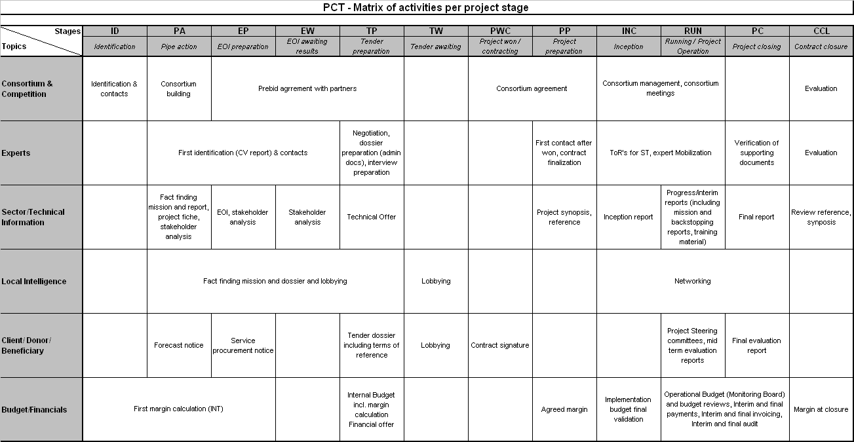

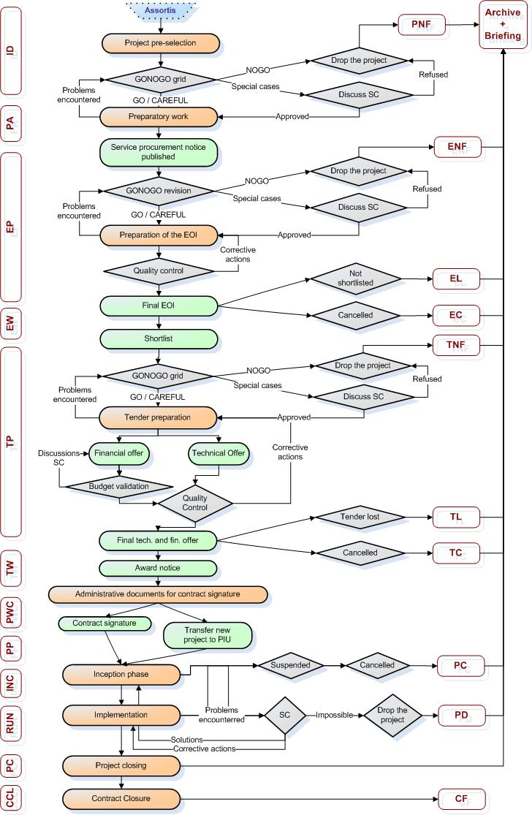

Cancelled

## CC